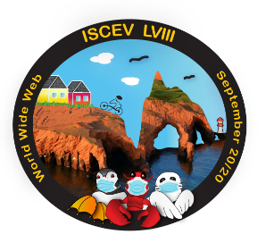**ISCEV 2020 OLYMPICS – GIFT GUESSING INDIFICATION FORM**

A set of past ISCEV gifts is showcased in the attached .pdf file.

The goal of your team is to correctly identify all these gifts to their corresponding ISCEV meeting

but be careful…not all items were actual past gifts and some meetings had multiple gifts!

|  |  |
| --- | --- |
| **GIFT #** | **Your answer (Please indicate the corresponding letter from the choices provided below)** |
| 1 | A |
| 2 | O |
| 3 | U |
| 4 | K |
| 5 | P |
| 6 | W |
| 7 | M |
| 8 | J |
| 9 | A) T B) |
| 10 | B |
| 11 | M |
| 12 | Q |
| 13 | I |
| 14 | R |
| 15 | S |
| 16 | H |
| 17 | N |
| 18 | L |
| 19 | G |
| 20 | F |
| 21 | D |
| 22 | E |
| 23 | W |
| 24 | V |
| 25 |  |
| 26 | B |
| 27 | K |
| 28 |  |
| 29 | T |
| 30 | U |
| 31 | C |
| 32 | O |
| 33 | N (Olympic helper) |
| 34 | K |
| 35 | O |

LIST OF PAST ISCEV MEETINGS:

A) Abbaye de Fontevraud (France)

B) Asilomar (USA)

C) Athens (Greece)

D) Banff (Canada)

E) Chiba (Japan)

F) Eilat (Israel)

G) Estoril (Portugal)

H) Glasgow (Scotland)

I) Hradec Králové (czech republic)

J) Hyderabad (India)

K) Lac Beauport (Québec)

L) Mie (Japan)

M) Mont-Orford (Québec)

N) Morgantown (USA)

O) Nagoya (Japan)

P) Oxford (UK)

Q) Padova Abano Terme (Italy)

R) Porto Rico (USA)

S) Singapore

T) Sydney (Australia)

U) Tübingen (Germany)

V) Valencia (Italy)

W) None of the above